 | IQVIATM Work Instruction Global Regulatory Affairs -  Review of Promotional Material for Marketed Products
Document Number and Revision:
CS_WI_RA0256 Revision 6
Document Owner:  Anja De Pauw | Author(s):  Helen Corley

PURPOSE
To describe the process for regulatory and medical review of Promotional Materials to confirm that the materials comply with applicable regulations and Codes of Practice.

SCOPE
  - This work instruction (WI) applies to all personnel in Global Regulatory Affairs engaged in the regulatory review, medical review and approval of promotional material for marketed products on behalf of customers, including when the review is sub-contracted to a third party.

  - This procedure applies to all projects that include the review of promotional material in the scope of work.

  - The materials in scope are:
- All materials containing company logos, trademarks, brand and product information for external use.
- Educational materials intended for training, awareness (including communication to HealthCare Professionals (HCPs), patients, customers) which contain product information or product claims and communicated through written, electronic, digital, verbal or audio/visual means. This includes materials for the Sales team and/or materials which may be disseminated to the consumer or professional customer in the form of advertising, publications, digital media, or verbal communications.
- Advertising and promotional materials aimed at customers, HCPs, which contain information which is pursuant to the company’s procedures, practices, services or products and communicated through written, electronic, digital, verbal or audio/visual means.
- Digital media (such as websites, mobile applications).
- Single letters to the customers regarding a promotional aspect of the business relationship (product launch/discontinuation communication, etc.).

Note that the abbreviated Summary of Product Characteristics (SmPC) known as the Prescribing Information with local pricing information has to be included as part of a promotional piece, or in some instances the full SmPC can be included where required by regional (EU) and local regulations.

  - Materials which are not considered promotional and so are NOT in scope are:
- Field Actions communications to Health Authorities (as this should be cleared by the Quality review board).
- Single letters to an individual customer regarding a non-promotional aspect of the business relationship (appointments, billing, etc.)
- Correspondence, possibly accompanied by material of a non-promotional nature, needed to answer a specific question about a medicinal product.
- Factual, informative announcements and reference material relating, for example, to pack changes, adverse-reaction warnings as part of general precautions, trade catalogues and price lists, provided they include no product claims.
- Non-promotional information relating to human health or diseases.
- Non-promotional, general information about companies (such as information directed towards investors or to current/prospective employees), including financial data, descriptions of research and development programmes, and discussion of regulatory developments affecting a company and its products.
- Materials or giveaways branded with a company or brand logo and following a company’s Healthcare Business Integrity process/guidance (e.g. Corporate brochures, notepads, refrigerator magnets, plastic bags etc.).
- Peer reviewed manuscripts and scientific material (submissions, posters and papers for conferences)
- Primary labels (adhesive labels, foils, sleeves, blisters), cartons (secondary packaging), package inserts, patient information leaflets, instructions for use
- European Summary of Product Characteristics (SmPC).
- Materials intended for patients and HCP linked to a Risk Management Plan, which follow a different regulatory approval process.

ROLES AND RESPONSIBILITIES
The following roles perform tasks described within this WI:

Role | Sections
Regulatory Project Manager (RPM) | 6.1
Regulatory Affairs (RA) Reviewer | 6.2
Medical Affairs (MA) Reviewer | 6.3

Regulatory Affairs Reviewer expertise:
The expertise required of the reviewer is:
- Clear understanding of Promotional Materials definition and what constitutes product claims.
- Clear understanding of what is considered acceptable support for product claims based on peer reviewed articles.

- Clear understanding of SmPC/approved labeling/approved product information and which elements are relevant in the review of promotional material.
- Working knowledge of therapeutic area to understand context of promotional piece.
- Good understanding of the local industry Code of Practice (if applicable) in terms of its practical application to the promotional piece (preferably including formal training on the Code if possible).
- Good understanding of country specific legislation and guidance for promotional material review.
- Where applicable, awareness of promotional pieces from all companies that are reported to the Regulatory Authority (RA) and the decision made whether the promotional pieces break the Code or not.

DEFINITIONS
  - Promotional Materials: Generic term that refers collectively to the following types of documents:
    - External communication materials referring, either directly or indirectly, to a medicinal product in printed or electronic forms (e.g., videos, Internet and customer website) and scripts for verbal presentations which promotes prescription, supply, administration, recommendation, sale, purchase or consumption of a medicinal product.
    - Advertising, promotion and training material (including press releases, TV advertising) for an approved medicinal product intended for, or currently marketed.
  - Copy Clearance: Formal process of appropriate departments (e.g. RA, MA, Legal, Marketing) reviewing and approving advertising & promotional material.
  - Healthcare Professional: Any member of the medical, dental, pharmacy or nursing professions or any other person who in the course of his/her professional activities may prescribe, purchase, supply or administer a medicinal product.

MATERIAL AND EQUIPMENT
Not Applicable.

PROCEDURE
  - Define Review Process
The process flow outlined in this section is depicted in Appendix A.

No: | Who: | Step: | When:
6.1.1 | RPM | Agrees the applicable points below with the customer:  - Whether the customer or IQVIA will be responsible for the medical scientific content review, which should be done before the regulatory review.  - Who will be responsible for regulatory review of each promotional piece.  - The role and responsibilities of each IQVIA personnel (or sub-contractor) for each country and the process to be used.  - The technology system to use (either the customer’s system or IQVIA’s system). If the customer’s sytem, this may be an internal company system or a commercially available system (such as VEEVA). If IQVIA, SharePoint and ePromo are options.  - The format of the promotional material review/approval sign- off sheet (or equivalent) indicating which regulatory and medical reviewers have reviewed, how comments were addressed (if this is not done within an electronic system such as ePromo) and who has approved the final version.  - The customer defines the countries targeted.  - The customer provides promotional material for review. | At start of project
6.1.2 |  | If IQVIA is providing the medical review, agrees with the customer:  - The promotional piece for review will be accompanied by all listed references, with text in each reference highlighted that is relevant to the claims.  - The audience, the purpose, proposed method of distribution and distribution date are provided with each promotional piece prior to sending the piece to the reviewers. | At start of project
6.1.3 |  | Sets up Project file (e.g. on IQVIA GRA shared drive) | At start of project
6.1.4 |  | Documents agreed process in Project Instructions. Refer to CS_WI_RA0273: Global Regulatory Affairs - Project Management of Standalone Projects. This should include archiving of project documents. | Following agreement with customer and throughout the project in case of updates
6.1.5 |  | Informs the Regulatory Authority of individuals who will be certifying promotional pieces. | At start of project, when required by local regulations or at customer request

  - Regulatory Review of Promotional Material

No: | Who: | Step: | When:
6.2.1 | RA  Reviewer | Checks compliance with current approved SmPC/approved labeling/approved product information/references/product registration certificate or equivalent, to ensure the claims or message are consistent with the terms of the product approval. | Throughout the project for each promotional piece
6.2.2 |  | Verifies that all statements are consistent with the approved indication, and approved product information (or prescribing information as applicable).
6.2.3 |  | Verifies compliance with the applicable Codes of Practice.
6.2.4 |  | Verifies compliance with the applicable promotional and advertising regulations (regional and/or local) and guidance.
6.2.5 |  | Verifies the translation into the local language is accurate compared to the Master version and compared to references, if applicable. (This requires the local regulatory expert to be fluent in the local language).
6.2.6 |  | Provides customer with written review comments and provides proposed wording amendments, if required.  Files written review as per Project Instruction.
6.2.7 |  | Works with customer, MA reviewer and, if applicable, the RPM to agree final version of promotional material.
6.2.8 |  | Completes promotional material review/approval sign-off sheet (or equivalent). An example is provided in Appendix B.  Files approval form as per Project Instruction. | Once the final version of promotional material has been agreed
6.2.9 |  | Updates the project-specific database/tracker of the status of reviews and approvals for each promotional item, as required by the RPM.
6.2.10 |  | If applicable, certifies compliance of the promotional material with applicable regulation. | If applicable and before submission to Regulatory Authority

  - Medical Review of Promotional Material (if applicable)

No: | Who: | Step: | When:
6.3.1 | RPM | If the customer’s scientific service is used, requests confirmation that the promotional piece is scientifically accurate from a medical perspective and files the confirmation as per Project Instruction. | Throughout the project for each promotional piece
6.3.2 |  | If IQVIA is providing the scientific review, assigns a medical reviewer.

No: | Who: | Step: | When:
6.3.3 | MA  reviewer | Conducts scientific review:  - Checks for scientific accuracy  - Checks that (complexity of) language used is appropriate for the targeted audience  - Confirms that the listed references are adequate to substantiate the claims  - Confirms message is appropriate from a medical perspective | Throughout the project for each promotional piece
6.3.4 |  | Provides customer with written review comments and provides proposed wording amendments, if required.  Files review comments as per Project Instruction. | After initial review of each promotional piece
6.3.5 |  | Works with customer, RA reviewer and, if applicable, the RPM to agree final version of promotional material.
6.3.6 |  | Completes promotional material review/approval sign-off sheet (or equivalent). An example is provided in Appendix B.  Files approval form as per Project Instruction. | Once the final version of promotional material has been agreed
6.3.7 |  | Updates the project-specific database/tracker of the status of reviews and approvals for each promotional item, as required by the RPM.

  - Notification or Submission to Regulatory Authority and approval (if applicable)

No: | Who: | Step: | When:
6.4.1 | RPM | If applicable, submits the promotional material to the Regulatory Authority | After review/approval of promotional material
6.4.2 |  | Responds to any comments received from the Regulatory Authority until Regulatory Authority is satisfied.  Files response as per Project Instruction.
6.4.3 |  | Provides the customer with a scanned or hard copy, as applicable, of the whole submitted package and corresponding acknowledgement of receipt, or corresponding approval when applicable.

- SUPPORTING DOCUMENTATION

DOCUMENT NUMBER | TITLE
ESOP References
7.1 CS_WI_RA0273 | Global Regulatory Affairs - Project Management of Standalone Projects

- SUPERSEDES

DOCUMENT NUMBER | TITLE | REVISION  NUMBER
8.1 CS_WI_RA0256 | Global Regulatory Affairs - Review of Promotional Material for Marketed Products | 5

- MODIFICATION FROM PREVIOUS REVISION

CHANGE | SECTION REFERENCE | JUSTIFICATION
Updated role names | 3 and 6 | For harmonization across all GRA SOPs
Additional documentation to be reviewed | 6.2.2 | Clarification of task

- APPENDICES
  - Appendix A: Process flow
  - Appendix B: Example of local material approval form

Appendix A: Process flow
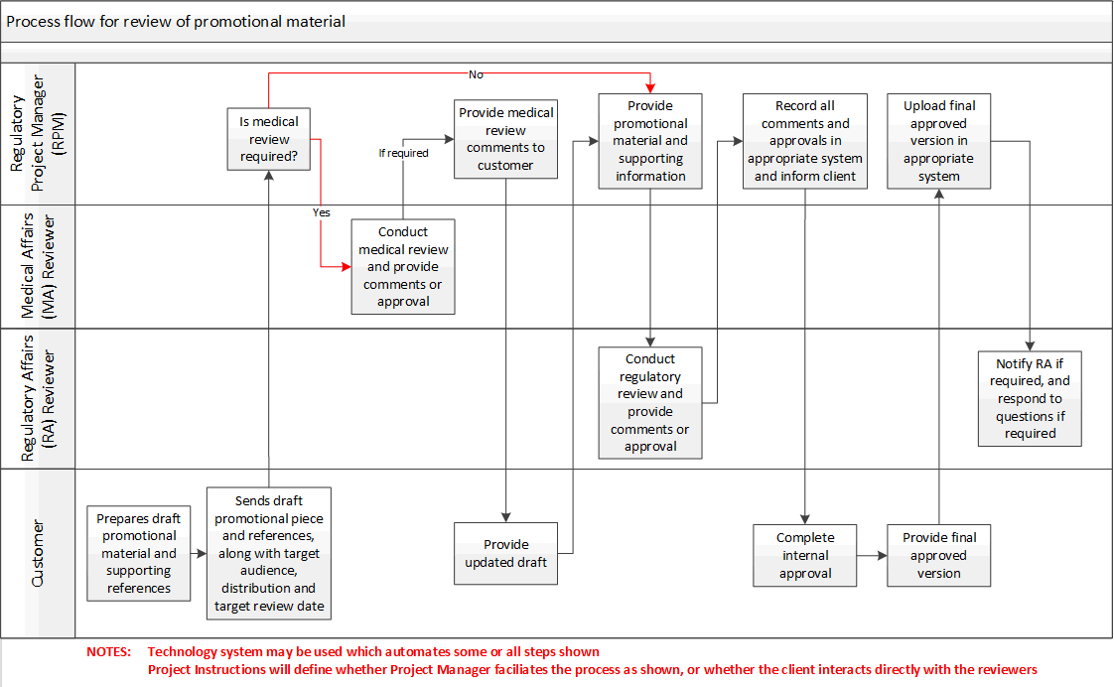

Appendix B: Example of local material approval form

Local material Approval form
Item Code | [Ref no.] | Material type | [e.g. flyer card]
Product Brand name
Objective
Audience
Method of distribution
Country |  | Language(s)
Date of Preparation |  | Expiry date
Date of SmPC/Prescribing information
Date of initiation for approval |  | Target approval date
Initiator name |  | Signature
Scientific advisor / Medical Affairs (MA) Reviewer name |  | Signature
Regulatory Affairs (RA) Reviewer name |  | Signature
Submission to local Regulatory Authority | Yes/No | Date of Submission
 |  | Date of Approval

Page 9 of 9
Copyright © 2012, 2014, 2016, 2018, 2019, 2021. IQVIA. All rights reserved. The contents of this document are confidential and proprietary to IQVIA Holdings Inc. and its subsidiaries. Unauthorized use, disclosure or reproduction is strictly prohibited.

UserName: Kemp, Jaco (q608126) Title:
Date: Wednesday, 30 June 2021, 12:16 PM Eastern Time Meaning: Signing this Document Indicates My Approval
================================================

UserName: Corley, Helen (q730385) Title:
Date: Wednesday, 30 June 2021, 12:42 PM Eastern Time Meaning: Signing this Document Indicates My Approval
================================================

UserName: Glizer, Veronica (q735279) Title:
Date: Wednesday, 30 June 2021, 12:54 PM Eastern Time Meaning: Signing this Document Indicates My Approval
================================================

UserName: Balani, Tarun (q830700) Title:
Date: Thursday, 01 July 2021, 12:24 AM Eastern Time Meaning: Signing this Document Indicates My Approval
================================================

UserName: Lobo, Zena (q833472) Title:
Date: Thursday, 01 July 2021, 03:25 AM Eastern Time Meaning: Signing this Document Indicates My Approval
================================================

UserName: Galea, Claudine (q769301) Title:
Date: Thursday, 01 July 2021, 03:45 AM Eastern Time Meaning: Signing this Document Indicates My Approval
================================================

UserName: Rahman, Maggie (q1033930) Title:
Date: Thursday, 08 July 2021, 12:03 PM Eastern Time Meaning: Signing this Document Indicates My Approval
================================================

UserName: Lewicky, Tamara (q730348) Title:
Date: Thursday, 08 July 2021, 12:08 PM Eastern Time Meaning: Signing this Document Indicates My Approval
================================================

